Graduate Alumni Survey
Updated: 08/01/2014

1. When did you graduate from UCCS?
Answer |  | Response | %
August 2012 |  | 4 | 3%
August 2013 |  | 7 | 5%
December 2012 |  | 23 | 18%
December 2013 |  | 11 | 9%
May 2012 |  | 41 | 32%
May 2013 |  | 43 | 33%
Total |  | 129 | 100%

2. What degree or degrees did you receive? Please check all that apply.
Answer |  | Response | %
Master of Arts (MA) |  | 49 | 36%
Master of Business Administration (MBA) |  | 32 | 23%
Master of Science (MS) |  | 19 | 14%
Master of Public Administration (MPA) |  | 18 | 13%
Doctor of Philosophy (PhD) |  | 10 | 7%
Bachelor of Arts (BA) |  | 10 | 7%
Master of Engineering (ME) |  | 6 | 4%
Bachelor of Science (BS) |  | 4 | 3%
Master of Sciences-Interdisciplinary (MSc) |  | 2 | 1%
Master of Criminal Justice (MCJ) |  | 2 | 1%
Certificate |  | 1 | 1%
Bachelor of Innovation (BI) |  | 0 | 0%
Doctor of Nursing Practice (DNP) |  | 0 | 0%

3. Please select your primary college of enrollment.
Answer |  | Response | %
College of Letters, Arts, and Sciences |  | 46 | 33%
College of Business |  | 31 | 22%
School of Public Affairs |  | 20 | 14%
College of Engineering and Applied Sciences |  | 16 | 12%
College of Education |  | 17 | 12%
Beth-El College of Nursing and Health Sciences |  | 8 | 6%
Total |  | 138 | 100%

4. What was your primary major?
Answer |  | Response | %
Business Administration |  | 26 | 20%
Public Administration |  | 16 | 12%
Counseling and Human Services |  | 12 | 9%
Educational Leadership, Research and Policy |  | 11 | 8%
Psychology |  | 11 | 8%
History |  | 9 | 7%
Curriculum and Instruction |  | 7 | 5%
Computer Science |  | 7 | 5%
Business |  | 4 | 3%
Sociology |  | 3 | 2%
Nursing |  | 3 | 2%
Mechanical Engineering |  | 3 | 2%
Criminal Justice |  | 2 | 2%
Health Care Sciences |  | 3 | 2%
Electrical Engineering |  | 3 | 2%
Applied Math |  | 2 | 2%
Computer Engineering |  | 3 | 2%
Biology |  | 2 | 2%
Communication |  | 1 | 1%
Physics |  | 1 | 1%
Mathematics |  | 1 | 1%
Computer Science and Security |  | 1 | 1%
Geography and Environmental Studies |  | 1 | 1%
Special Education |  | 1 | 1%
Political Science |  | 0 | 0%
Applied Science |  | 0 | 0%
Distributed Studies |  | 0 | 0%
Spanish |  | 0 | 0%
Womens and Ethnic Studies |  | 0 | 0%
Visual and Performing Arts |  | 0 | 0%
Applied Geography |  | 0 | 0%
Biochemistry |  | 0 | 0%
Game Design and Development |  | 0 | 0%
English |  | 0 | 0%
Anthropology |  | 0 | 0%
Chemistry |  | 0 | 0%
Interdisciplinary Studies |  | 0 | 0%
Nursing Practice |  | 0 | 0%
Economics |  | 0 | 0%
Philosophy |  | 0 | 0%
Total |  | 133 | 100%

5. If you majored in Health Sciences, please select your area of emphasis.
Answer |  | Response | %
Health Promotion (MS) |  | 2 | 67%
Sport Nutrition (MS) |  | 1 | 33%
Sports Medicine: Athletic Training (MS) |  | 0 | 0%
Sports Medicine: Strength and Conditioning (MS) |  | 0 | 0%
Pre-Professional (PPT) |  | 0 | 0%
Health and Wellness Promotion (HWP) |  | 0 | 0%
Medical Technology/Medical Laboratory Science (MDT) |  | 0 | 0%
Nutrition (NUT) |  | 0 | 0%
Senior Fitness Instructor (SFI) |  | 0 | 0%
Strength and Conditioning (Sports Conditioning and Training) (SPC) |  | 0 | 0%
Allied Health (ALH) |  | 0 | 0%
Total |  | 3 | 100%

6. During your studies as a student at UCCS, were you enrolled full-time?
Answer |  | Response | %
Yes |  | 105 | 76%
No |  | 20 | 14%
Sometimes |  | 13 | 9%
Total |  | 138 | 100%

7. Did you work off campus while enrolled at UCCS?
Answer |  | Response | %
Yes, Full-time |  | 75 | 54%
Yes, Part-time |  | 30 | 22%
No |  | 33 | 24%
Total |  | 138 | 100%

8. What is your current status?
Answer |  | Response | %
Employed full time |  | 96 | 70%
Employed part-time |  | 10 | 7%
Seeking employment |  | 18 | 13%
Not seeking employment |  | 2 | 1%
Enrolled student (pursuing another degree) |  | 10 | 7%
Retired |  | 2 | 1%
Total |  | 138 | 100%

9. What is your current occupation?
Title:
2nd Grade teacher
Academic Advisor
Academic Advisor
Access to Justice Coordinator
Adjunct Instructor
Adjunct lecturer & Instructor
Admin/Legal Assistant
Admin Assistant
Admin Assistant
Administrative Assistant II
Administrative asst
Admissions Counselor
Budget & Operations Coordinator
Business Area Manager
Clinical Assistant, ATC
Commanding Officer
Consultant
Contracting Officer
Coordinator of Greek Life and Community Engagement
Counselor
Counselor
Counselor
Counselor
Dean of Students
Development Account Executive
Director
Director of Business Administration and Compliance
Director of College Counseling
Director of Housing and Citizen Services
Director of Membership
Division Assistant
Driver Trainer
E/O Engineer
Engineer
Engineer
Engineer
Family Nurse Practitioner
Firmware Engineer
Global IT Security Compliance Director
HR Director
Instructor of Mathematics
ISR AEF FAM
Lay Up Associate
Lead Engineer
Librarian
Major
membership rep
Microbiology Technologist
Personalized Learning Project Coordinator
Personal trainer
Physician
Police Officer
Police Officer
Postdoctoral Fellow
prenatal plus care coordinator
Product Manager
Product Marketin
program manager
Program Manager
Program Manager
Program Manager
Project Director
Public Affairs Specialist
Public Health Director/Administrator
Research Assistant
Restaurant manager
School Counselor
School Counselor
Secretary
Senior Academic Advisor
Senior Fitness Specialist
Senior Software Application Development Engineer
Senior Systems Analyst
Social Media and Communication Specialist
Software Engineer
Software Engineer
Software Engineer
Software Engineer Sr
Soldier
Spanish Teacher
Sr. Director Product Marketing
Sr Principal Engineer
Sr Systems Engineer
System/Software Engineer
Systems Analyst
Systems Engineer
Teacher
Technical Services Supervisor
Teen Court Coordinator
Testing and Alternative Media Specialist
Therapist
U.S. Air Force Pilot
Veterans Service Representative
Weather Officer

10. Is your job related to your UCCS major?
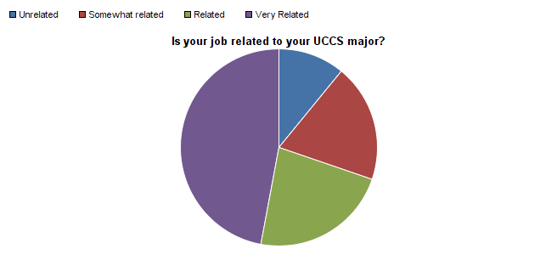

Question | Unrelated | Somewhat related | Related | Very Related | Total Responses | Mean
Is your job related to your UCCS major? | 10.92% | 19.33% | 22.69% | 47.06% | 119 | 3.06

11. Where do you live?
Answer |  | Response | %
In Colorado Springs/or surrounding areas. |  | 81 | 60%
Outside of Colorado Springs, but in Colorado. |  | 14 | 10%
Outside of Colorado. |  | 37 | 28%
Outside of the United States. |  | 2 | 1%
Total |  | 134 | 100%

12. What is your current annual salary?
Answer |  | Response | %
Less than $20,000 |  | 17 | 14%
$20,000 to $29,999 |  | 7 | 6%
$30,000 to $39,999 |  | 16 | 13%
$40,000 to $49,999 |  | 21 | 17%
$50,000 to $59,999 |  | 7 | 6%
$60,000 to $69,999 |  | 7 | 6%
$70,000 to $79,999 |  | 6 | 5%
$80,000 to $89,999 |  | 7 | 6%
$90,000 to $99,999 |  | 5 | 4%
$100,000 to $129,999 |  | 11 | 9%
$130,000 to $149,999 |  | 2 | 2%
$150,000 or more |  | 4 | 3%
Do not wish to disclose |  | 14 | 11%
Total |  | 124 | 100%

13. Please estimate what you think your salary might be had you not graduated from UCCS.
Answer |  | Response | %
Less than $20,000 |  | 18 | 15%
$20,000 to $29,999 |  | 9 | 8%
$30,000 to $39,999 |  | 19 | 16%
$40,000 to $49,999 |  | 20 | 17%
$50,000 to $59,999 |  | 10 | 9%
$60,000 to $69,999 |  | 6 | 5%
$70,000 to $79,999 |  | 8 | 7%
$80,000 to $89,999 |  | 7 | 6%
$90,000 to $99,999 |  | 6 | 5%
$100,000 to $129,999 |  | 8 | 7%
$130,000 to $149,999 |  | 1 | 1%
$150,000 or more |  | 5 | 4%
Total |  | 117 | 100%

14. In which sector of the economy are you employed?
Answer |  | Response | %
Education, Training and Library |  | 31 | 25%
Other, please specify |  | 26 | 21%
Military |  | 13 | 10%
Healthcare Practitioners and Technicians |  | 8 | 6%
Computer and Mathematics |  | 8 | 6%
Community and Social Services |  | 7 | 6%
Architecture and Engineering |  | 5 | 4%
Office and Administrative Support |  | 5 | 4%
Management |  | 5 | 4%
Life, Physical and Social Science |  | 4 | 3%
Healthcare Support |  | 3 | 2%
Food Preparation/Serving |  | 2 | 2%
Personal Care and Service |  | 2 | 2%
Legal |  | 2 | 2%
Production |  | 1 | 1%
Sales |  | 1 | 1%
Construction and Extraction |  | 1 | 1%
Arts, Design, Entertainment, Sports and Media |  | 1 | 1%
Transportation and Material Moving |  | 1 | 1%
Protective Services |  | 0 | 0%
Building and Grounds Cleaning, Maintenance |  | 0 | 0%
Installation, Maintenance and Repair |  | 0 | 0%
Farming, Fishing, and Forestry |  | 0 | 0%
Business and Financial Operations |  | 0 | 0%
Total |  | 126 | 100%

Other, please specify
City Government
Communication/Marketing/Public Relations
customer service
Defense
Department of Defense
Fitness
Government/public sector - public affairs, public relations
Information and Technology
It's a school, but my job relates more to helping kids in poverty get an education.
Looking for work
n/a
Public Accounting
Research
Software Engineering
Sport & Recreation
State Government
unemployed

15. How would you rate UCCS in the following areas?
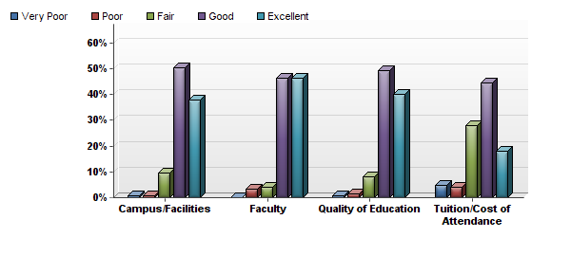

Question | Very Poor | Poor | Fair | Good | Excellent | Total Responses | Mean
Campus/Facilities | 1 | 1 | 11 | 57 | 43 | 113 | 4.24
Faculty | 0 | 4 | 5 | 57 | 57 | 123 | 4.36
Quality of Education | 1 | 2 | 10 | 60 | 49 | 122 | 4.26
Tuition/Cost of Attendance | 6 | 5 | 34 | 54 | 22 | 121 | 3.67

16.
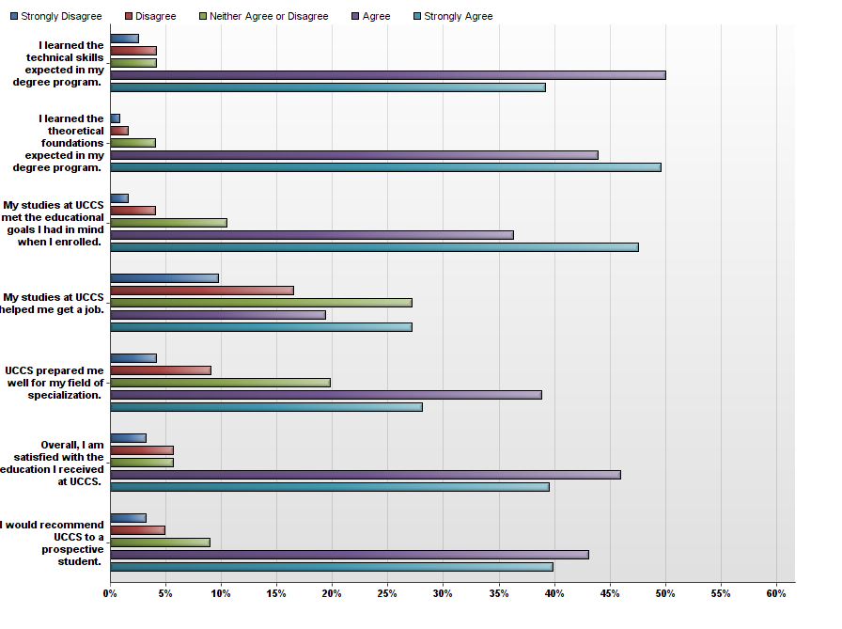

Question | Strongly Disagree | Disagree | Neither Agree or Disagree | Agree | Strongly Agree | Total Responses | Mean
I learned the technical skills expected in my degree program. | 3 | 5 | 5 | 60 | 47 | 120 | 4.19
I learned the theoretical foundations expected in my degree program. | 1 | 2 | 5 | 54 | 61 | 123 | 4.40
My studies at UCCS met the educational goals I had in mind when I enrolled. | 2 | 5 | 13 | 45 | 59 | 124 | 4.24
My studies at UCCS helped me get a job. | 10 | 17 | 28 | 20 | 28 | 103 | 3.38
UCCS prepared me well for my field of specialization. | 5 | 11 | 24 | 47 | 34 | 121 | 3.78
Overall, I am satisfied with the education I received at UCCS. | 4 | 7 | 7 | 57 | 49 | 124 | 4.13
I would recommend UCCS to a prospective student. | 4 | 6 | 11 | 53 | 49 | 123 | 4.11

17. How would you rate the overall quality of your education at UCCS, in the following areas?
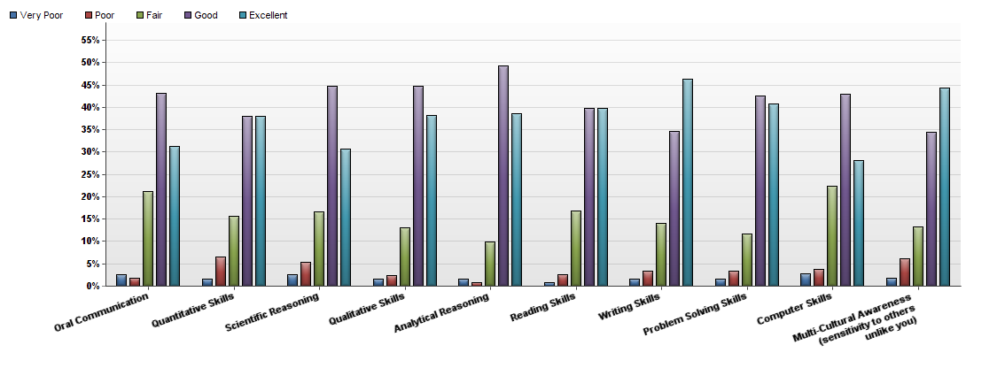

Question | Very Poor | Poor | Fair | Good | Excellent | Total Responses | Mean
Oral Communication | 3 | 2 | 25 | 51 | 37 | 118 | 3.99
Quantitative Skills | 2 | 8 | 19 | 46 | 46 | 121 | 4.04
Scientific Reasoning | 3 | 6 | 19 | 51 | 35 | 114 | 3.96
Qualitative Skills | 2 | 3 | 16 | 55 | 47 | 123 | 4.15
Analytical Reasoning | 2 | 1 | 12 | 60 | 47 | 122 | 4.22
Reading Skills | 1 | 3 | 19 | 45 | 45 | 113 | 4.15
Writing Skills | 2 | 4 | 17 | 42 | 56 | 121 | 4.21
Problem Solving Skills | 2 | 4 | 14 | 51 | 49 | 120 | 4.18
Computer Skills | 3 | 4 | 24 | 46 | 30 | 107 | 3.90
Multi-Cultural Awareness (sensitivity to others unlike you) | 2 | 7 | 15 | 39 | 50 | 113 | 4.13

18. Please rate the quality of services you feel you received while attending UCCS.
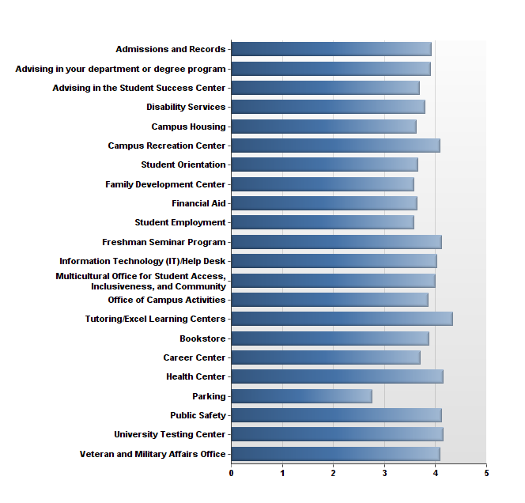

Rate the Quality of Services: | Very Poor | Poor | Fair | Good | Excellent | Total Responses | Mean
Admissions and Records | 2.48% | 7.44% | 15.70% | 44.63% | 29.75% | 121 | 3.92
Advising in the Student Success Center | 12.20% | 2.44% | 17.07% | 41.46% | 26.83% | 41 | 3.68
Advising in your department or degree program | 6.78% | 7.63% | 12.71% | 33.90% | 38.98% | 118 | 3.91
Bookstore | 4.20% | 0.84% | 23.53% | 47.06% | 24.37% | 119 | 3.87
Campus Housing | 7.69% | 7.69% | 23.08% | 38.46% | 23.08% | 13 | 3.62
Campus Recreation Center | 4.08% | 6.12% | 8.16% | 40.82% | 40.82% | 49 | 4.08
Career Center | 7.32% | 14.63% | 14.63% | 26.83% | 36.59% | 41 | 3.71
Disability Services | 10.00% | 0.00% | 30.00% | 20.00% | 40.00% | 10 | 3.80
Family Development Center | 0.00% | 14.29% | 28.57% | 42.86% | 14.29% | 7 | 3.57
Financial Aid | 8.45% | 8.45% | 22.54% | 32.39% | 28.17% | 71 | 3.63
Freshman Seminar Program | 0.00% | 0.00% | 33.33% | 22.22% | 44.44% | 9 | 4.11
Health Center | 0.00% | 0.00% | 12.12% | 60.61% | 27.27% | 33 | 4.15
Information Technology (IT)/Help Desk | 1.74% | 4.35% | 17.39% | 42.61% | 33.91% | 115 | 4.03
Multicultural Office for Student Access, Inclusiveness, and Community | 4.17% | 4.17% | 12.50% | 45.83% | 33.33% | 24 | 4.00
Office of Campus Activities | 3.70% | 0.00% | 22.22% | 55.56% | 18.52% | 27 | 3.85
Parking | 22.94% | 22.94% | 22.02% | 20.18% | 11.93% | 109 | 2.75
Public Safety | 2.30% | 1.15% | 13.79% | 48.28% | 34.48% | 87 | 4.11
Student Employment | 8.89% | 6.67% | 20.00% | 46.67% | 17.78% | 45 | 3.58
Student Orientation | 5.26% | 10.53% | 19.30% | 43.86% | 21.05% | 57 | 3.65
Tutoring/Excel Learning Centers | 0.00% | 2.78% | 11.11% | 36.11% | 50.00% | 36 | 4.33
University Testing Center | 0.00% | 5.00% | 15.00% | 40.00% | 40.00% | 20 | 4.15
Veteran and Military Affairs Office | 0.00% | 12.00% | 12.00% | 32.00% | 44.00% | 25 | 4.08

19. Approximately how many faculty members took an interest in your educational and career goals?
Answer |  | Response | %
0 |  | 12 | 10%
1-2 |  | 34 | 28%
2-3 |  | 21 | 17%
3+ |  | 56 | 46%
Total |  | 123 | 100%

20. What one piece of advice would you give to a new student attending UCCS?
Text Response
Do not work full time.
That really depends on whether they are a graduate or undergraduate student.
Stay focused! Lots of (good) distractions...but lots of ways to get off track.
Finish!
make connections with faculty
Network! Nobody really likes to present in front of a large group of people, but it is a very very important skill to acquire.
Not all instructors are the same and always ask for clarification whether it be for an assignment or your final grade.
Find a staff member that is doing something you care about and try to participate.
Don't let Mom and Dad control your life or hold your hand, you will never get anywhere in life if you expect others to do things for you.
Study well fro good grades and take use of the career center.
Don't go, if you are over the age of 45. College too concentrated on young students on this largely commuting campus.
Order books online from amazon.com it will save you $$$ on textbooks.
Car pool if possible to share parking costs; watch out for speed traps on Austin Bluffs Parkway
BE mindful of the experience you are about to have.. don't worry so much about the future.. just enjoy your time on campus.. and try to meet as many diverse individuals that you can... and pay attention to the required classes!
This University is challenging and will push you.
Try to get in state tuition from the beginning because the office fights every attempt, like driving your parents car in colorado and its not in your name so it has your previous state's plates and insurance, which resulted in me being denied and having to take out more loans, which will take me an additional 10 or so years to pay off.
Don't be afraid to ask questions in class.
My biggest piece of advice would be to get to know your professors. Not all will be great, but when you do find a great professor, they will surely have a profound impact on your academic, career, and personal life.
plan to spend a lot of money!!!
study hard or just go home and don't waste both of our time.
Have the drive and willpower to see it through, because your only going to get out of it what you put into it.
It seems like a great school for freshman that need a small campus in a fairly large city with plenty of things to do. It's great for continuing education students that want night classes.
Don't be afraid of the faculty: They are here to help you succeed.
Don't take a Dr. Wilcox class
Take the time to talk to your professors when you are having a problem. They are usually very willing to help if they can.
Get involved in at least one club or activity.
College means you make decisions for your life and yours alone - nobody else can make them for you. Don't blame others for being unsuccessful - you can be your own driving force to make whatever change you want happen in your life so make college count because it may be the only chance you get to make a difference in the world.
Get to know your professors outside of class
Speak up in class and challenge the status quo.
Spend as much time as possible interacting with your fellow classmates.
Just do it, you will be treated as a person, not a number or name. The staff gets to know you personally.
You have to seek an education at UCCS, because it will not force a good one upon you.
Be prepared to work hard.
You're on your own.
Look out for administration, they are good at screwing people over (or losing your important documents).
Take advantage of all the UCCS offers you.
UCCS is a great school with professors who care about their students. Take advantage of opportunities given to you during your time there. And if you work full time, don't give up!
Take the time to pick the brains of the students and faculty you have around you.
Pace yourself
Get involved or else you may get bored!
Get out
parking is awful so get there early
Attend class, don't just do all your work on-line. Meet people that are in your career field, there are people that will be willing to help you. There may be doors that open as a result.
Don't attend the program I attended.
Go somewhere else!!!
Enjoy it. It goes fast.
Show up early or there's no parking.
Remember you are with others in the same boat. The curriculum is so heavily team focused and each person brings different experience and skills, part of your roll is to learn what makes people different, why they are successful at particular tasks or areas, what they do different. Taking this approach won't give you extra grades on any particular assignment, but if you take the time to do it, you will build relationships and you will understand your own strengths, weaknesses and blind spots so that you can overcome them and over time build stronger teams resulting in great grades. You don't have to be good at everything, just know how you can contribute the best.
Talk with your professors
Attend conferences to connect with like mined people and to learn more outside of the classroom!
You get out of it what you put into it.
Parking: get there early, or be prepared to hike.
Study hard
Live in walking distance.
Study Hard, Learn alot, Be Happy
Try to take advantage of all the resources that are offered on campus - like signing up to work with a librarian for a research project or attending a resume review work shop etc.
Put the effort into going beyond the classwork. Push yourself to learn and experience more than just the program.
Be ready to work- it is going to be an uphill climb, but worth every moment!
Most of the time, it is not WHAT you know, but WHO you know that helps you make it in this world.
Get connected with an advisor in your focus area as soon as possible.
Pay for parking or they will get you.
Keep focused and finish.
if you are young - get involved in a lot of activities and clubs if you are older - focus on tailoring your degree to include your past experiences
Make the best out of it
Work part-time because you will need the cash. Work a few years in the real world before you decide on a major/path in life, so you don;t waste money on college if you don't need it.
Keep an open mind as you may learn to look at things in a new way.
Don't take surveys made by the professor themselves, only take the official ones.
Use the rec center, because even if you live too far away to use it, you have to pay for it anyway.
Advocate for your education and ask questions if you are uncertain....
Pay for college yourself, don't use financial aid and live close so you can bike to work. Also, major in history, it's a really good program.
Go mechanical engineering or nursing or go somewhere else.
Listen to others and take responsibility
Be realistic when scheduling time to do reading and home work
Get involved
Go to another school.
To learn to speak out and stand up for yourself. (Also, take a public speaking course if available-very valuable).
Get really clear on scheduling and your overall requirements and progress. The requirements were not clear in the beginning and I took a class I did not need to take. If taking classes online, don't let that annoying progress bar during tests get to you. It can cause anxiety and that makes testing harder!
Use the Learning Centers - the tuturs are super helpful.
In order to meet desire near and long termed goals, each student must be prepare to stay engaged and focus in their program of study to include building a solid student and professional network which may provide leads to employment opportunities.
Think and discuss.
Try to take as many on campus classes as you can. UCCS has an amazing campus from the views to the buildings. You don't feel like you're really "stuck" in a classroom.
Don't do a Graduate level degree without getting a job first unless you want to be a professor (at least for Engineering students). New graduates I have interviewed at work (from any school, not just UCCS) which have gone straight through from undergrad to masters without getting a job first are woefully unprepared for what work is like and have a skewed view of expectations. They tend to be too 'academic' and are not able to manage real world expectations.
Do not pursue the degree that you want. Pursue the degree that has the classes that you will enjoy the most.
Nice place to Study

21. Are you affiliated with the military?
Answer |  | Response | %
My spouse is in the military. |  | 3 | 2%
I am a member of the military. |  | 8 | 6%
I am a veteran. |  | 17 | 14%
My mother or father is in the military. |  | 7 | 6%
No, I am not affiliated with the military. |  | 83 | 67%
Other, please specify. |  | 11 | 9%

Other, please specify.
Reserves
retired Army officer
My company is a military contractor
My father, brother, and many other family members have served in the military.
I used my father's post-9/11 GI Bill to attend
Dept of Defense Civilian
brother
my father is retired military
I am a defense contractor
Retired Military
My stepmother was in the military.

22. Were you a Colorado resident when you enrolled at UCCS?
# | Answer |  | Response | %
1 | Yes |  | 97 | 78%
2 | No |  | 28 | 22%
 | Total |  | 125 | 100%

23. Are you a first-generation student?
# | Answer |  | Response | %
1 | Yes |  | 34 | 27%
2 | No |  | 88 | 70%
3 | Not sure |  | 3 | 2%
 | Total |  | 125 | 100%

24. Please mark the highest level of education achieved by your parent(s).
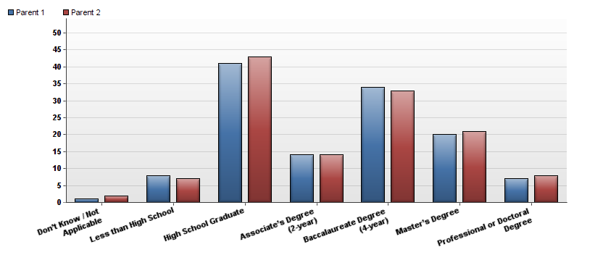

Question | Parent 1 | Parent 2 | Total Responses
Don’t Know / Not Applicable | 1 | 2 | 3
Less than High School | 8 | 7 | 15
High School Graduate | 41 | 43 | 84
Associate’s Degree (2-year) | 14 | 14 | 28
Baccalaureate Degree (4-year) | 34 | 33 | 67
Master’s Degree | 20 | 21 | 41
Professional or Doctoral Degree | 7 | 8 | 15

25. How many dependents (children or elderly persons) did you care for in your household while you were enrolled at UCCS?
Answer |  | Response | %
0 |  | 79 | 63%
1 |  | 16 | 13%
2 |  | 16 | 13%
3 |  | 10 | 8%
4 |  | 3 | 2%
5+ |  | 1 | 1%
Total |  | 125 | 100%

26. What would you have done had you not attended UCCS?
Answer |  | Response | %
I would have attended a college/university outside of the Colorado Springs metro area. |  | 46 | 37%
I would have attended a different college/university in my immediate area. |  | 30 | 24%
Other |  | 21 | 17%
I would have delayed attending college. |  | 16 | 13%
I would have enrolled in an online program. |  | 15 | 12%
I would not have attended college anywhere. |  | 15 | 12%

