New Alumni Destinations Survey (2019+)
October 21st 2021, 4:41 pm MDT
today - Please mark the status that best fits your situation today.
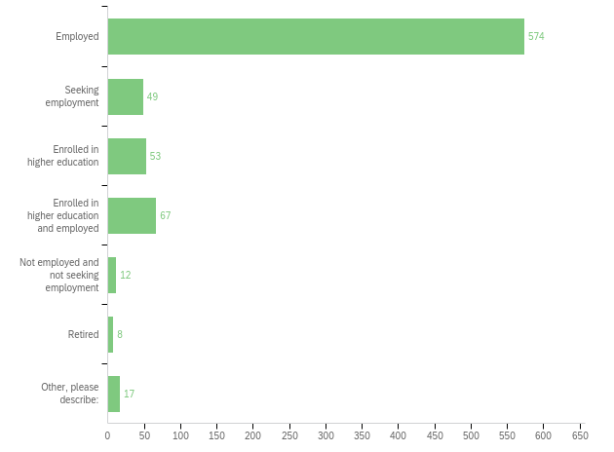

covid - How has the COVID-19 pandemic affected your employment status or education plans? Please mark all that apply.
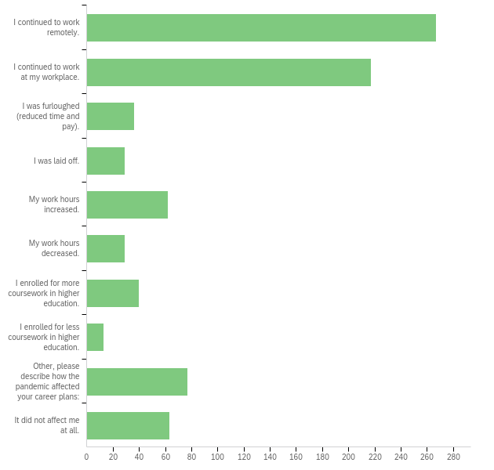
job - Could you provide more detail about your current or most recent job? This info can help UCCS develop partnerships in the community and beyond.

Job title:
Growth Lead
Mortgage loan processor
Assistant Director, Gateway Program Seminar
Recruiter
Director of Communications and Membership
Professional Counselor Associate
VP ACCOUNTING
Instructor
Solutions Advisor
Workplace Planning Consultant
RN
Licensed Prof Counselor
Asst food and beverage manager
Program Director, ASL & Deaf Studies
Corporate Services Manager
Program Manager
Global Education Facilitator
Cell Technician
Logistics Management Specialist Fellow
Performance Dietitian
Technical Support Analyst I
TRIO advisor
Special education teacher
Radiologic Technologist
6th Grade Teacher
Program Manager
Director of Clinical Education
Elementary School Teacher
Community Volunteer Ambassador
teacher
Registered Nurse
Intern
3rd Grade Teacher
Social Media
Social Service Supervisor
Substitute Teacher
Licensed clinical social worker
Manager
Contracting Officer
Research Engineer
Master Instructor
Student Director
Prevention & Outreach Manager
Chief Information Security Officer
Community Telehealth Access Coordinator
Manager, Community Giving and mountain access
Controller
Lecturer
engineer
Enrollment Services Coordinator
Admin assistant
English Teacher
Digital Marketing Specialist
Patient Representative
FNP-C
Graduate Assistant
Security Associate
Special Projects Coordinator
Healthcare Administrator
Lab Technician
Contracting Officer
Lead Software Developer
Realtor
Assistant Store Manager
Opera Singers
Licensed professional counselor candidate
ESL Teacher
Manager
CSM
Employee Health and Wellness Coordinator
State teacher 1
Anesthesiology Resident
Certified Residential Appraiser
Chief People Officer
Wellness & Internal Programs Administrator
Psychiatric Mental Health Nurse Practitioner
School Counselor
Office manager
Insurance Agent
Campus and Community Coordinator
Tutor
Senior Project Manager
Teaching Assistant
Sr. Financial Analyst
Mechanical Engineer
Warehouse Manager
Police Officer
Medical Laboratory Scientist
Project Accountant
Teacher
Software engineer
HR Generalist
Mental Health Professional
Financial Analyst
Dietitian
Mentor and CLDE Coordinator
IT Systems Engineer
Application Engineer
Graduate Student Success Counselor
Lecturer
Audit Associate
CFO
Systems Engineer
Product Development Manager
Executive Officer
Director of Operations
Front End Web Developer
Counselor
Credit Analyst
Ret. Plan Analyst
Manager Admissions Process Operations
Validation Engineer I
Clinical dietitian
Systems Engineer
Director of Behavioral Health
Program Associate
Teacher
Design Engineer
Sports performance coach
Americorps Service Member
Software Developer Senior
Systems Administrator
Parking Services Supervisor
Program Director
Engineer
Benefits Manager
CLDE Teacher
Program Manager of Clinical Quality for IT
Teacher
Adjutant/Captain
FNP-C
Engineer
Lead Teacher
IT Audit
Clinical Psychologist
Deputy Program Manager
Manufacturing Engineer
Systems Engineer
Special Education Teacher
Director, Office of Professional Formation
Registered Nurse
Director
School Counselor
Software Engineer
Emergency Management Specialist
Senior Systems Test Engineer
Gifted Education Facilitator
Process Analyst
Kindergarten teacher
Senior Accountant
Paralegal
Clinical Instructor / ED RN (2 jobs)
RN
Nurse
Customer Relationship Advocate
Loan Processor
Education & Information Officer
Elementary Special Education Teacher
Assistant Director, Sport Management
Associate Vice President
Assessment Specialist
Systems administrator
Project Coordinator
Teacher
Assistant Dean
Quality Control Analyst
Box Office Assistant Manager
Operations and Investment Manager
Registered Nurse
Educational Aide
Front Office Assistant
Director of Community Training and Empowerment
Senior Manager, Strategy Communications
Donor Relations Specialist
Director of Strategy, Exploration, and Execution
Logistics Manager
Director
Marketing Manager
RN
Instructor
Writer/Author
Primary Therapist
GIS Specialist
Associate Financial Service Representative
Pharmacist
Customer Service
Manager of Product Support, CRM Analyst
Director of Health Services
Credit risk analyst
Psychotherapist
Software engineer
Medical Assistant
SQA Intern
Renewal account manager
Family Medicine physician, hospitalist
Staff Accountant
Branch Chief
Analyst
Admissions Counselor
RN
Executive Director
Newborn Care Specialist
Talent Acqusition Professional
Sr Global Real Estate Development Project Manager
Process Analyst
Registered Nurse
Senior Embedded Firmware Engineer
Global Compensation Design Consultant
Software engineer
Housing Occupancy Specialist
Project Manager
Human Resources Program Manager / HR & Faculty Affairs Program Manager
Property\UBIT Accountant
Development Coordinator
RN
Staff Scientist
Program Manager
Communication Faculty
HR Generalist
Special Education Teacher
Police Officer
Project Manager
Administration assistant
School Counselor
Program Director
Research RN
Marketing and community development manager
R&D Engineer
Software Engineer
residence hall manager
Cyber security analyst
Program Manager
Junior Cybersecurity Analyst
Diversity, Equity, & Inclusion Program Manager
Family Help Specialist
Police officer
Technical advisor
Teacher
VR developer
Academic Advisor
Senior Librarian
Business Services Assistant
Director, Admissions, Recruitment, and Enrollment
RN
Overnight stocker
Photographer
Pharmacy technician
Leadership Portfolio Director
Behavioral Health Counselor
Instructor
Server
Teacher
Artist
Teacher
Membership Services Consultant
President
Communications Team Leas
Financial Analyst
Firmware engineer
IC Design Engineer
Office Marketing Coordinator
Na
Research Assistant
Nurse
Fraud Claims Investigator
Teacher
Lead Teacher
Technical Professional II
Charge RN
Software Engineer
Business Management Analyst
Auto Adjuster III
Registered Nurse
Instructional Coach
Special education teacher
Advice Line Nurse
Executive Director
Retirement Client Specialist
Student Midwife and director of community assessment for the local pregnancy center
Victim Advocate
Contracts Manager
Wrapping up role with local nonprofit on 8/31 to move to new role
Systems Engineer
Physician assistant
Junior Software Engineer
Office Administrator
Staffing coordinator
Nurse
academic advisor
Operations Manager
Government Affairs Specialist
Workforce Development Specialist
Senior Engineer
Assistant Director of Admissions
LIFE COACH
Chief Scientist
Accountant
Paramedic
Police Officer
Chief Systems Engineer
Business Analyst
Research scientist/ director of r&d
Education & Information Officer
Defense Support of a Civil Authorities Executive Seminar and Table Top Exercise Specialist
Counter Representative
Children’s Ministry Director
Security officer
Toddler Lead Teacher
Business Analyst
Assistant Professor
Autonomy/AI Engineer
R.N. (L&D)
Military Outreach Coordinator
IT analyst
Budget Analyst
Loan Specialist sba
Transfer Admissions Counselor
RN
Sr Lecturer
Deli Clerk
Networking & Marketing Manager
Executive Assistant
Director of Advising and Learning Enhancement
MD
Sales associate
Registered nurse
Transition Specialist
Center Manager
Tax compliance supervisor
RN,BSN
Assistant Dean
RN
General Manager
Dishwasher
Dentist
Registered Nurse
Proposal coordinator
Engineering Contingent Worker
Registered Nurse
Education and Training technician
Regulatory Specialist
NGB Services Specialist
Program Analyst
Project Management
HR Manager
Administrative & Compliance Assistant
IT Supervisor
UI Developer
Clinical nurse I
AMTS Test Sys Dev
Sales Program Manager
Fourth Grade Science and Social Studies Teacher
Assistant Program Director
Exercise Physiologist
Assistant Program Director
Operational Planner
CEO
CFO
Account Manager
Director of Marketing
RN
Graduate Research Assistant
ED/LD Teacher
Critical Care RN
Technical Support Senior Professional
Marketing Specialist
Engineer I
Learning Delivery Specialist
Family nurse practitioner
RN
Software Engineer
Coordinator of Student Initiatives
RN
Program Coordinator of Membership and Communications
Wound & Ostomy Case Manager
Manager of Student Accounts
Clinical nurse coordinator in the operating room
IT Security Analyst
Accountant
CNC Operator
Registered Nurse
Therapist
Senior LDRP Associate
Program Assistant 1
Cartographer
cataloging assistant
Lab Director
Professional Research Assistant
Family Nurse Practitioner
Clinical Nurse
Administrative Prof.
Physical Education Teacher
Associate Broker
Online Grocery Picker
Waitress Manager
Chemist
Emergency Medicine Physician
Gallery Preparator & Events Director
Operations Research Analyst
Academic Advisor
Compliance Project Manager, Community Development Division
Auto tech
Assistant Program Director
Director of Member Services
Maintenance supervisor
Conservative & Sustainability Manager
Graduate Assistant
Compliance survey specialist
Chemistry Instructor
Teacher
Teacher
Artist & Art Therapist
Operations Accounting Supervisor
Pretrial Services Specialist
Wellness Center Office Manager
Financial Aid Advisor
Land Law Examiner
Registered Dietitian
Project Manager
Management
Admissions Assistant
Assistant Manager
Software Engineer
Professional Research Assistant
Patient Experience Program Manager
Coordinator fo Civic Engagement
program coordinator
Medical Laboratory Technician
Social Media Strategist
Finance and HR Professional
Assistant Professor
Assistant Director of First-Year Rhetoric and Writing
Software Intern
Business Analyst
Financial Program Manager
Behavior Therapist
Attorney
CNA
Attorney
RN
Analyst
Research Analyst
Behavior Specialist/instructor
Manager, Product Development
Contracting Officer
Director
VillaKids Associate
Mainframe Hardware Systems Analyst
Teacher
Subrogation Specialist
Project Engineer
Brand Manager
Claims Adjuster
Lead Case Manager
Scrum Master
Associate Research Specialist
Operations Associate
Sr.Data Scientist
Senior Project Manager
Desk Agent
Closing Agent
Contracting Specialist
Engineering Tech
Physical Therapist
Individual Giving Officer
Editor
Software developer
Drafter
Project Manager
Donor Center Technician
Business Manager
RN
Program Asst. I
Subcontracts Administrator
Custodian
Legal Assistant
Maintenance Worker
Head Coach
Systems integration analyst
Teacher
Program Advisor
Program Manager
Anti-Money Laundering Analyst
Marketing Ambassador
Accounting Technician
Project Manager
CAD Drafter
Water Distribution Operator
Financial Analyst
Substitute Teacher
Director of Product Development
Data manager
Personal Finance Specialist
Assistant Director of Development
Desktop Support Lead
Operations Analyst
Admissions Counselor
Instructional Support Specialist
Physical therapy tech
Registered Nurse
Senior Manager
Senior Engineer
Manager, ERC CIP
commissioning engineer
Associate
Microcomputer/Network Technician
Medical lab assistant supervisor
Job Location & Development Coordinator
Financial Administrator
Technical Analyst associate
Retail Manager
Law firm administrator
Medicaid Coordinator
Enrollment Strategy Analyst
Sales
Operations Leadership Associate
Instructor
Kids club supervisor
Network Administrator
Graduate Research Assistant
Driver
Administrative Assistant III
Specialty
EAP Coordinator
GIS Analyst
Consultant
Audit Manager
Clinical Counselor
Assistant Professor of Computer Science
Administrative Assistant /AP AR clerk
Lecturer
Research Assistant
Case Manager
Writer
Graduate student instructor
Property Manager
eComm Marketing Assistant
Life and Health Representative
Software Engineer
Fire & Theft Claims Representative
IT Web Developer
Financial Compliance Auditor
research assistant
Tutor
Athletic trainer
Clinical Supervisor
Member Services Coordinator
Program Manager
Developed Engineer
Caseworker
Lecturer
Registered Behavior Technician
Nurse
Professional Research Assistant
Compensation analyst
PGA Golf Professional
Lead Software Engineer
RF Engineer
Lidar Technician II
Academic Specialist

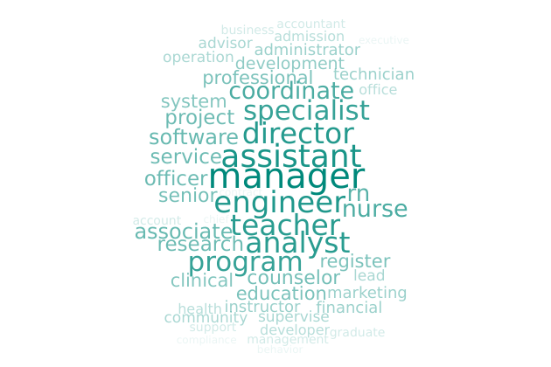

soc - Which of the following occupational categories is the best fit for your current (or most recent) job? These categories are based on the Standard Occupational Classification System.
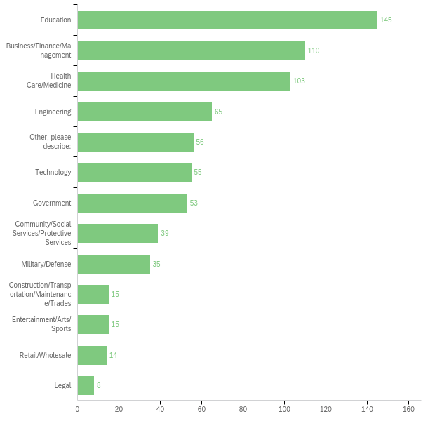
jobchar - Please indicate if the following statements apply to your current (or most recent) job.
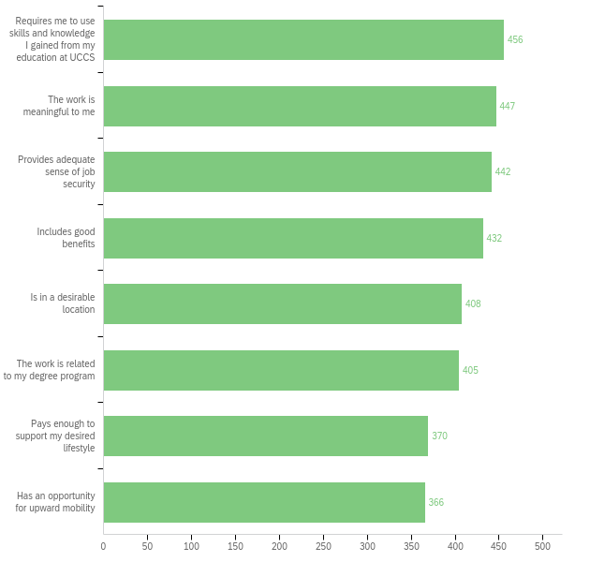
salary - Please estimate your current annual salary. Note: adjust your estimate to reflect the salary as if you are working 100% time. For example, if you are earning 25k and working 50% time, then your annual estimate should be 50k.
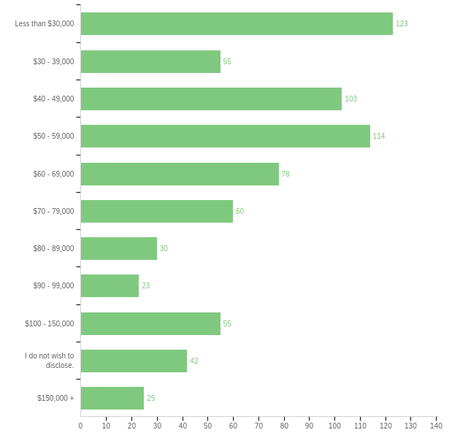
enhance - Did your degree enhance your salary?
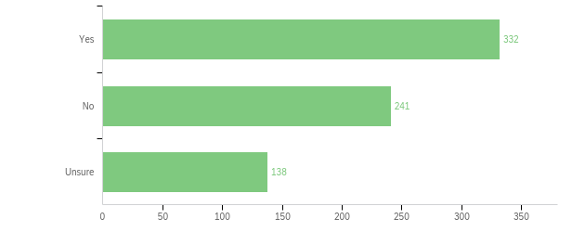

promote - Did your degree help you advance or be promoted within your career?
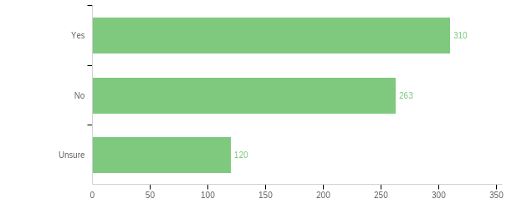

educ - Have you enrolled in another degree/certificate program after graduating from UCCS?
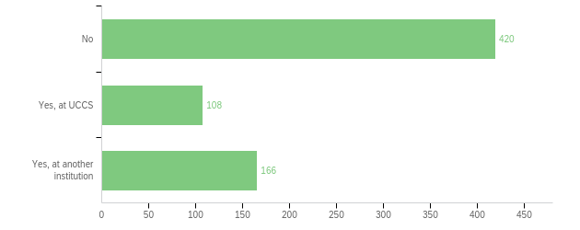

degprog - What type of degree/certificate program did you pursue? Check all that apply.
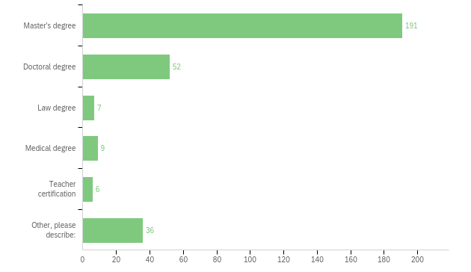

inst - Where did you pursue another degree (or where are you attending now)?

Name of institution: | Location (state): | Area of study:
Colorado State University | CO | Higher Education Admin
Arizona State University |  | Communications
Club managers association of america | CO | Golf business
Drake University | Des Moines, Iowa | Doctor of Philosophy in Education
Capella | Online | MSN-Ed
Jacksonville State University | Alabama | Elementary Education
Colorado College | Co | reading
University of Southern California | CA | Social work
Syracuse University | New York | Project Management
University of Colorado | Boulder, Colorado | American History
DePaul University | Illinois | Educational leadership
Texas A&M University | Texas | Sport Management
Webster Univ. | Colorado | Business
Real Estate School | South Carolina | Real Estate
Eastman School of Music | Rochester, NY | Voice Performance and Opera
Adams state University | Alamosa CO | Clinical mental health
Grand Canyon University | AZ | M.Ed. TESOL
Kansas City University of medicine and biosciences | MO | Medicine
University of Denver | Colorado | Healthcare Management
Regis College | MA | MSN
University of Denver | Colorado | Health administration
The Institutes | Online | CPCU
University of Delaware | Delaware | Sociology and Criminal Justice
Johns Hopkins University | D.C. | Economics
Nunya | Somewheresistan | Studies
University of Washington | Seattle, WA | Business Analysis
Arizona State University |  | Behavioral Medicine
denver college of nursing |  | BSN
Penn State World Campus |  | Accounting
BUMC | Dallas, Texas | Nutrition
University of Missouri School of Medicine | Missouri | Medicine
University of Denver | Colorado | Juris Doctorate
UC Denver | CO | INFS
University of Colorado Denver | Colorado | CJ
St Marys University | Texas | Law/Public Administration
George Washington university | Dc | Nursing
Fielding Graduate University | California | Clinical Psychology
ASU | Arizona | Technical Communications
University of Oklahoma | Oklahoma | Accounting
Grand Canyon University | AZ | NP program
University of Denver | CO | Law
University of Colorado Denver | Denver, CO | Leadership for Educational Equity in Higher Education
University of denver | Colorado | Website design
Augusta University | GA | Curriculum and Instruction
University of California | CA | Biochemistry
Pickens Technical College | Colorado | Cosmetology
Arizona State University | Online | Nonprofit Leadership and Management
Chamberlain University
University of Colorado school of pharmacy | Colorado | Pharmacy
University Of Wisconsin | WI | Speech Language Pathology
University of Nebraska | Lincoln, NE | MBA
University of Saint Mary | Kansas | Physical therapy
Rocky Vista University College of Osteopathic Medicine | Parker, CO | Medicine
Western Governors University | Utah | MSN
Auburn University | Auburn, Al | Construction Management
CU Anschutz | CO | MSN
CU Boulder | Colorado | Mechanical Engineering
UNC | Colorado | MBA
Pikes Peak Community College | Colorado | Peace Officer Training Certification
Capella university | MN | Counseling
University of Denver | CO | Library and Information Sciences
University of Northern Colorado | Colorado | Biomedical Sciences
University of North Dakota | North Dakota | Forensic Psychology
CU Denver | CO | MBA
Southern New Hampshire | New Hampshire | Finance
XJTLU | Jiangsu, China | Sustainable Energy Technology
CSU-p | CO | AGACNP/FNP DNP
National College of Midwifery | Distance learning - HI | Midwifery/Women’s Health
Penn State | PA | Homeland security
Rocky mountain college | Montana | Physician assistant studies
PPCC | Colorado Springs | Paramedicine
 |  | Data Management
University of Northern Colorado | Colorado | Sport and Exercise Science
University of Edinburgh | Scotland | Evolutionary Genetics
CU | CO | MD
Central Michigan University | MI | MSA
Mississippi State University | Mississippi | Aerospace engineering
Michigan State University | Lansing, MI | GIS
Creighton | Nebraska | Dentistry
Grand canyon University | Phoenix, AZ | Elementary education
Regent University | Virginia | TV production
Walden University | MN | Public Policy & Administration
Colorado State Univeristy | Ft. Collins, CO | IOP
Suffolk University | Massachusetts | Healthcare Administration
PennState | State College, PA | MBA
Maryville University | Missouri | MBA - Sport Business Management
Colorado State University | Colorado | Biomedical Sciences
Baruch College | New York, NY | MBA
CU Boulder | CO | Law
Austin Peay State University | TN | Industrial and Organizational Psychology
Samford University | Birmingham, AL | Doctor of Nursing Practice
The Cleveland Clinic | OH | Wound, ostomy, and continence
Regis University | CO | Software Engineering
University of Denver | Colorado | International Studies
University of Minnesota Twin Cities | MN | Master of Business Administration
University of Missouri | Columbia Missouri | Geography
San Jose State university | California (online) | Library and Information Science
University of Washington | Washington | Molecular and Cellular Biology
Stony Brook University | New York | Philosophy
Colorado State University-Pueblo | CO | Teacher Education
UC San Diego | CA | MD and PhD
Uniformed Services University | MD | Medicine
UNC School of Law, and now Georgetown Law | DC | Law
University of Arizona | Arizona | Social Psychology
University of Denver | Colorado | Natural Resource Management
Georgia Southern | GA | MAT
Naropa University | Colorado | Transpersonal Counseling Psychology & Art Therapy
University of Colorado | Denver | MBA
CU Denver | Colorado | Anesthesia
Rochester Institute of Technology | New York | Screenwriting
Seward County Community College | KS | Med lab tech
University of Oklahom | Norman | Strategic Communication
University of Colorado Denver | Denver, CO | Rhetoric and Writing
William and Mary Law School | Virginia | Law
Colorado State University | Online | MBA
Arizona State Unviversity | Arizona | Special Education ABA
Penn State Dickinson Law | Carlisle PA | Law
South University | GA | Masters of Physician Assistant
University of Denver | CO | Law
Chamberlain | IL | FNP
Arizona State University | Arizona | Education
Cu anschutz | CO | MPH
University of San Diego | California | Counseling
Chicago Community College | Il
Temple University | PA | History
Newman University | Colorado | Social Work
Gannon University | Pennsylvania | Electrical engineering
University of Wisconsin Madison | Wisconsin | Endocrinology and Reproductive Physiology
Ashford University | Vermont | Organizational Management
Columbia University | New York | Physical therapy
AMU | Online | Medical
Washington University in St louis | MO | OT
Grand Canyon University | Arizona | Nursing
Regis | Denver | Cyber security
Colorado State | CO | M.Ed
Grand Rapids Theological Seminary | Michigan | Religion
CU Denver | Colorado | Curriculum and Instruction
UT | Knoxville | SCM
Central washington Unviersity | Washington | Geology
CU Boulder (completed Masters), Virginia Tech (currently doing PhD) | Colorado and Virginia | Computer Science and Computer Engineering
CSU Pueblo | Colorado | English
Colorado Technical University | Colorado | MBA
Liberty University | Virginia | Counselor
CSU | Colorado | Neuroscience
Barry university | Florida | Physician assistant
University of Denver | Denver, CO | Communication Management
University of Michigan | Michigan | Molecular, cellular, and developmental biology
cu boulder | co | physics
TBD
Northcentral University | Utah | Marriage and Family Therapy
Human Resources institute | CO | Human resources
University of Colorado | Boulder | Engineering Management

relocate - Did you relocate after or since earning your UCCS degree?
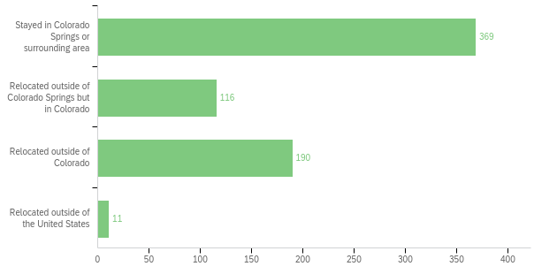

firstjob - When did you get your first job after graduating from UCCS?
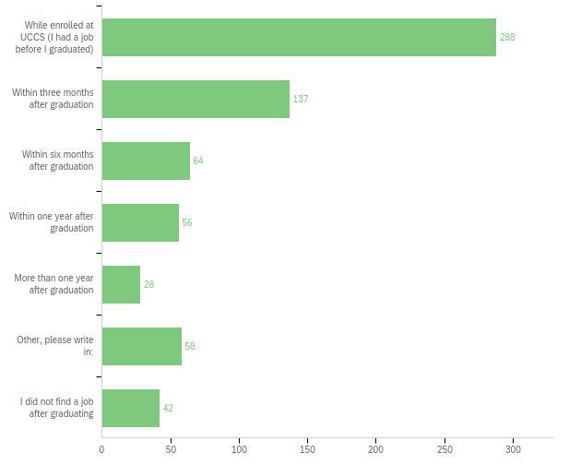

activities - Please indicate your level of agreement with the following statements pertaining to your experiences at UCCS.
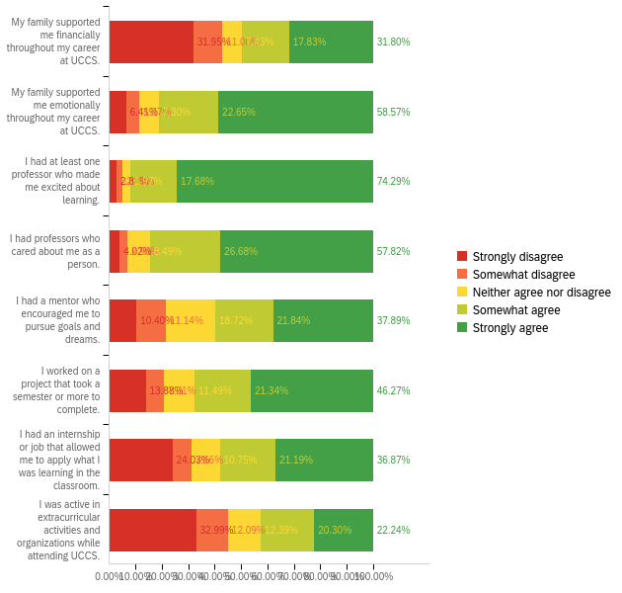
satis - Please indicate your level of agreement with the following statements pertaining to your experiences at UCCS.
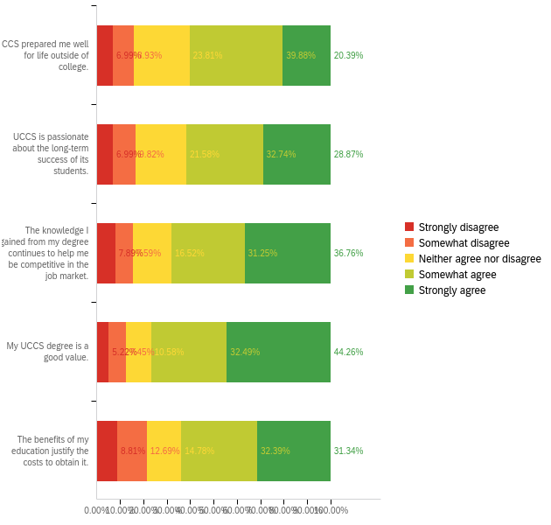
promoter - On a scale from 0-10, how likely are you to recommend UCCS to a potential student?
