Undergrad Alumni Survey
Last Modified: 08/01/2014

1. When did you graduate from UCCS?
Answer |  | Response | %
August 2012 |  | 9 | 2%
August 2013 |  | 12 | 3%
December 2012 |  | 64 | 15%
December 2013 |  | 55 | 13%
May 2012 |  | 128 | 31%
May 2013 |  | 145 | 35%
Total |  | 413 | 100%

2. What degree or degrees did you receive? Please check all that apply.
Answer |  | Response | %
Bachelor of Arts (BA) |  | 163 | 36%
Bachelor of Science (BS) |  | 155 | 35%
Master of Arts (MA) |  | 49 | 11%
Master of Business Administration (MBA) |  | 32 | 7%
Master of Science (MS) |  | 19 | 4%
Master of Public Administration (MPA) |  | 18 | 4%
Doctor of Philosophy (PhD) |  | 10 | 2%
Bachelor of Innovation (BI) |  | 8 | 2%
Master of Engineering (ME) |  | 6 | 1%
Certificate |  | 3 | 1%
Master of Sciences-Interdisciplinary (MSc) |  | 2 | 0%
Master of Criminal Justice (MCJ) |  | 2 | 0%
Doctor of Nursing Practice (DNP) |  | 0 | 0%

3. Please select your primary college of enrollment.
Answer |  | Response | %
College of Letters, Arts, and Sciences |  | 207 | 46%
College of Business |  | 100 | 22%
College of Engineering and Applied Sciences |  | 50 | 11%
Beth-El College of Nursing and Health Sciences |  | 37 | 8%
School of Public Affairs |  | 33 | 7%
College of Education |  | 20 | 4%
Total |  | 447 | 100%

4. What was your primary major?
Answer |  | Response | %
Business Administration |  | 46 | 11%
Business |  | 48 | 11%
Psychology |  | 34 | 8%
Biology |  | 26 | 6%
Communication |  | 21 | 5%
History |  | 22 | 5%
Nursing |  | 22 | 5%
Computer Science |  | 20 | 5%
Public Administration |  | 17 | 4%
English |  | 16 | 4%
Sociology |  | 14 | 3%
Mechanical Engineering |  | 14 | 3%
Criminal Justice |  | 15 | 3%
Counseling and Human Services |  | 12 | 3%
Educational Leadership, Research and Policy |  | 11 | 3%
Geography and Environmental Studies |  | 14 | 3%
Health Care Sciences |  | 11 | 3%
Anthropology |  | 8 | 2%
Curriculum and Instruction |  | 7 | 2%
Political Science |  | 10 | 2%
Physics |  | 5 | 1%
Philosophy |  | 4 | 1%
Visual and Performing Arts |  | 6 | 1%
Electrical Engineering |  | 6 | 1%
Game Design and Development |  | 3 | 1%
Computer Engineering |  | 6 | 1%
Applied Math |  | 2 | 0%
Applied Science |  | 0 | 0%
Spanish |  | 1 | 0%
Special Education |  | 2 | 0%
Womens and Ethnic Studies |  | 2 | 0%
Applied Geography |  | 0 | 0%
Biochemistry |  | 2 | 0%
Chemistry |  | 2 | 0%
Distributed Studies |  | 1 | 0%
Economics |  | 1 | 0%
Nursing Practice |  | 1 | 0%
Computer Science and Security |  | 1 | 0%
Interdisciplinary Studies |  | 0 | 0%
Mathematics |  | 2 | 0%
Total |  | 435 | 100%

5. If you majored in Health Sciences, please select your area of emphasis.
Answer |  | Response | %
Strength and Conditioning (Sports Conditioning and Training) (SPC) |  | 3 | 27%
Nutrition (NUT) |  | 3 | 27%
Health Promotion (MS) |  | 2 | 18%
Health and Wellness Promotion (HWP) |  | 2 | 18%
Sport Nutrition (MS) |  | 1 | 9%
Sports Medicine: Strength and Conditioning (MS) |  | 0 | 0%
Medical Technology/Medical Laboratory Science (MDT) |  | 0 | 0%
Sports Medicine: Athletic Training (MS) |  | 0 | 0%
Senior Fitness Instructor (SFI) |  | 0 | 0%
Pre-Professional (PPT) |  | 0 | 0%
Allied Health (ALH) |  | 0 | 0%
Total |  | 11 | 100%

6. During your studies as a student at UCCS, were you enrolled full-time?
Answer |  | Response | %
Yes |  | 394 | 88%
No |  | 24 | 5%
Sometimes |  | 28 | 6%
Total |  | 446 | 100%

7. Did you work off campus while enrolled at UCCS?
Answer |  | Response | %
Yes, Full-time |  | 144 | 32%
Yes, Part-time |  | 186 | 42%
No |  | 116 | 26%
Total |  | 446 | 100%

8. What is your current status?
Answer |  | Response | %
Employed full time |  | 263 | 59%
Employed part-time |  | 56 | 13%
Seeking employment |  | 59 | 13%
Not seeking employment |  | 4 | 1%
Enrolled student (pursuing another degree) |  | 63 | 14%
Retired |  | 2 | 0%
Total |  | 447 | 100%

9. What is your current occupation?
Title:
Adjunct lecturer & Instructor
Admin/Legal Assistant
Admin Assistant
Admin Assistant
Administrative Assistant
Administrative Assistant II
Administrative Asst
Admissions Counselor
Associate Programmer Analyst
Business Area Manager
Business Developer
Business Process Analyst
CFO
Clinical Nurse
CNA
Commanding Officer
Community Affairs Manager
Consultant
Contract Administrator
Copy Editor
Copywriter
Customer Service Agent
Dean of Students
Decision Support Analyst
Design Engineer
Development Account Executive
Director, Scribe Program
Director of Membership
District Executive
Driver Trainer
E/O Engineer
Electrical Engineer
Enablement Administrator
Engineer
Engineer
Financial Analyst
Fiscal Representative
Genius
GIS Intern
hairstylist
History Teacher/ Coach
Implementation Specialist
Information Specialist
Instructor of Mathematics
IS Compliance Lead
IT Client Service Tech Lead
Laboratory tech
Lead Account Executive
Lead Engineer
Library Aide
Major
Math Fellow
Mechanical Engineer
Mechanical Engineer
Membership and Events Coordinator
Microbiologist
Nurse
Office Manager
Office Staff assistant
Online Course Facilitator
Physician
Project Coordinator
Project Director
Public Affairs Officer
Public Health Director/Administrator
RAM Service Specialist
Receptionist
Receptionist
Registered Nurse
Research Assistant
residence hall manager
RN
Sales associate
Sales Representative
Security Officer
Senior Academic Advisor
Senior Fitness Specialist
shipping Manager
Social Worker
Software Engineer
Software Engineer
Software Engineer
Software Engineer
Software engineer
Software Engineer Associate
Spanish Teacher
SpEd Resource Paraprofessional
Sr. Analyst
Sr Systems Engineer
Staff Accountant
System/Software Engineer
Teacher
Teacher
Technical Representative
Third Grade Teacher
Web Developer
Workflow Coordinator

10. Is your job related to your UCCS major?
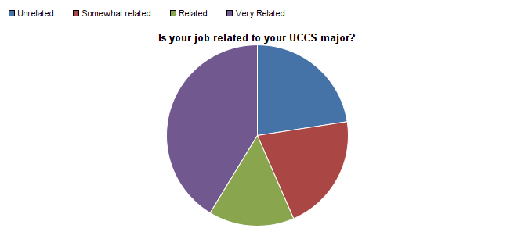

Question | Unrelated | Somewhat related | Related | Very Related | Total Responses | Mean
Is your job related to your UCCS major? | 22.55% | 20.92% | 15.22% | 41.30% | 368 | 2.75

11. Where do you live?
Answer |  | Response | %
In Colorado Springs/or surrounding areas. |  | 276 | 65%
Outside of Colorado Springs, but in Colorado. |  | 53 | 12%
Outside of Colorado. |  | 92 | 22%
Outside of the United States. |  | 6 | 1%
Total |  | 427 | 100%

12. What is your current annual salary ?
Answer |  | Response | %
Less than $20,000 |  | 102 | 26%
$20,000 to $29,999 |  | 55 | 14%
$30,000 to $39,999 |  | 61 | 16%
$40,000 to $49,999 |  | 49 | 13%
$50,000 to $59,999 |  | 27 | 7%
$60,000 to $69,999 |  | 21 | 5%
$70,000 to $79,999 |  | 7 | 2%
$80,000 to $89,999 |  | 9 | 2%
$90,000 to $99,999 |  | 7 | 2%
$100,000 to $129,999 |  | 11 | 3%
$130,000 to $149,999 |  | 2 | 1%
$150,000 or more |  | 4 | 1%
Do not wish to disclose |  | 31 | 8%
Total |  | 386 | 100%

13. Please estimate what you think your salary might be had you not graduated from UCCS.
Answer |  | Response | %
Less than $20,000 |  | 128 | 34%
$20,000 to $29,999 |  | 86 | 23%
$30,000 to $39,999 |  | 57 | 15%
$40,000 to $49,999 |  | 36 | 10%
$50,000 to $59,999 |  | 13 | 3%
$60,000 to $69,999 |  | 12 | 3%
$70,000 to $79,999 |  | 8 | 2%
$80,000 to $89,999 |  | 9 | 2%
$90,000 to $99,999 |  | 8 | 2%
$100,000 to $129,999 |  | 11 | 3%
$130,000 to $149,999 |  | 1 | 0%
$150,000 or more |  | 7 | 2%
Total |  | 376 | 100%

14. In which sector of the economy are you employed?
Answer |  | Response | %
Other, please specify |  | 85 | 22%
Education, Training and Library |  | 63 | 16%
Healthcare Practitioners and Technicians |  | 35 | 9%
Computer and Mathematics |  | 32 | 8%
Business and Financial Operations |  | 30 | 8%
Sales |  | 20 | 5%
Military |  | 16 | 4%
Office and Administrative Support |  | 16 | 4%
Architecture and Engineering |  | 14 | 4%
Arts, Design, Entertainment, Sports and Media |  | 13 | 3%
Community and Social Services |  | 13 | 3%
Management |  | 11 | 3%
Healthcare Support |  | 11 | 3%
Food Preparation/Serving |  | 8 | 2%
Personal Care and Service |  | 5 | 1%
Life, Physical and Social Science |  | 5 | 1%
Legal |  | 4 | 1%
Construction and Extraction |  | 4 | 1%
Transportation and Material Moving |  | 3 | 1%
Protective Services |  | 3 | 1%
Building and Grounds Cleaning, Maintenance |  | 1 | 0%
Production |  | 1 | 0%
Installation, Maintenance and Repair |  | 1 | 0%
Farming, Fishing, and Forestry |  | 0 | 0%
Total |  | 394 | 100%

Other, please specify
aviation and computer
Business Owner
Cashier
Childcare
Childcare
City Government
Communication/Marketing/Public Relations
Currently Unemployeed
customer service
Customer service
Defense
Environment health and safety
Fitness
Geospatial, Mapping
Golf
Government
Government/public sector - public affairs, public relations
Grad student
Hospitality
Hospitality
I am not employed
Information and Technology
It's a school, but my job relates more to helping kids in poverty get an education.
IT Applications
Library Services
Life, physical and social science, and archaeology
Looking for work
Manufacturing
Nanny
Natural gas transportation
Non-profit
not employed
Not working
Pharmaceutical Consulting
Politics
Public Accounting
Research
Research
Software Development
Software Engineering
Sport
Sport & Recreation
Sport Management
State Government
Student
Summer Camp
tutor
UCCS Work study
Unemployed
utilities

15. How would you rate UCCS in the following areas?
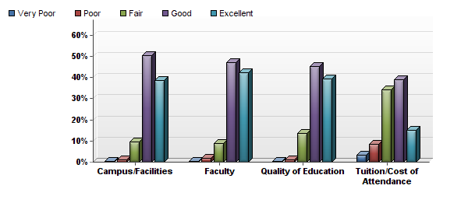

Question | Very Poor | Poor | Fair | Good | Excellent | Total Responses | Mean
Campus/Facilities | 2 | 4 | 37 | 194 | 149 | 386 | 4.25
Faculty | 1 | 7 | 35 | 186 | 167 | 396 | 4.29
Quality of Education | 1 | 5 | 54 | 179 | 156 | 395 | 4.23
Tuition/Cost of Attendance | 13 | 33 | 135 | 153 | 59 | 393 | 3.54

16.
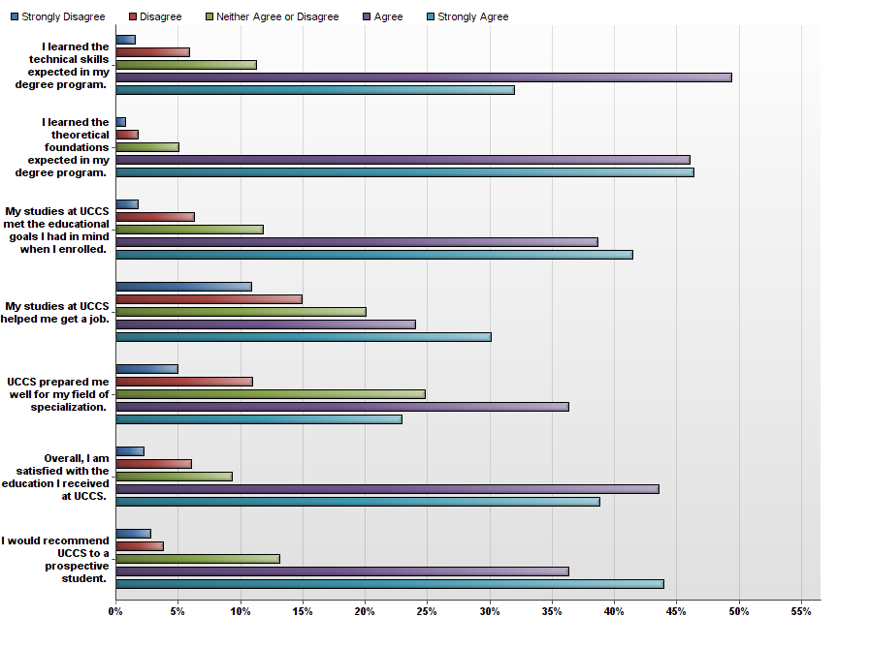

Question | Strongly Disagree | Disagree | Neither Agree or Disagree | Agree | Strongly Agree | Total Responses | Mean
I learned the technical skills expected in my degree program. | 6 | 23 | 44 | 193 | 125 | 391 | 4.04
I learned the theoretical foundations expected in my degree program. | 3 | 7 | 20 | 182 | 183 | 395 | 4.35
My studies at UCCS met the educational goals I had in mind when I enrolled. | 7 | 25 | 47 | 154 | 165 | 398 | 4.12
My studies at UCCS helped me get a job. | 38 | 52 | 70 | 84 | 105 | 349 | 3.48
UCCS prepared me well for my field of specialization. | 19 | 42 | 95 | 139 | 88 | 383 | 3.61
Overall, I am satisfied with the education I received at UCCS. | 9 | 24 | 37 | 173 | 154 | 397 | 4.11
I would recommend UCCS to a prospective student. | 11 | 15 | 52 | 144 | 174 | 396 | 4.15

17. How would you rate the overall quality of your education at UCCS, in the following areas?
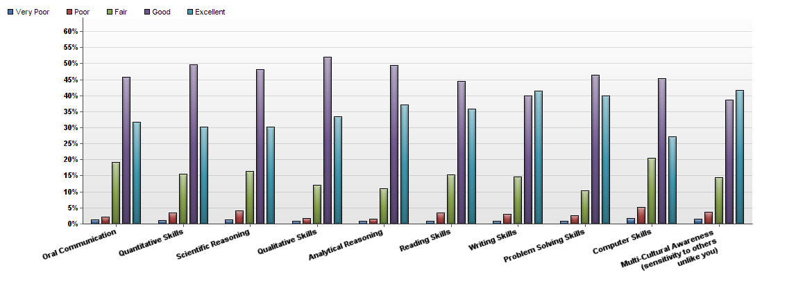

Question | Very Poor | Poor | Fair | Good | Excellent | Total Responses | Mean
Oral Communication | 5 | 8 | 75 | 178 | 123 | 389 | 4.04
Quantitative Skills | 4 | 13 | 60 | 191 | 116 | 384 | 4.05
Scientific Reasoning | 5 | 15 | 60 | 177 | 111 | 368 | 4.02
Qualitative Skills | 3 | 7 | 47 | 203 | 131 | 391 | 4.16
Analytical Reasoning | 3 | 6 | 43 | 193 | 145 | 390 | 4.21
Reading Skills | 3 | 13 | 57 | 166 | 134 | 373 | 4.11
Writing Skills | 3 | 12 | 57 | 154 | 160 | 386 | 4.18
Problem Solving Skills | 3 | 10 | 40 | 181 | 156 | 390 | 4.22
Computer Skills | 6 | 19 | 76 | 168 | 101 | 370 | 3.92
Multi-Cultural Awareness (sensitivity to others unlike you) | 6 | 14 | 54 | 144 | 155 | 373 | 4.15

18. Please rate the quality of services you feel you received while attending UCCS.
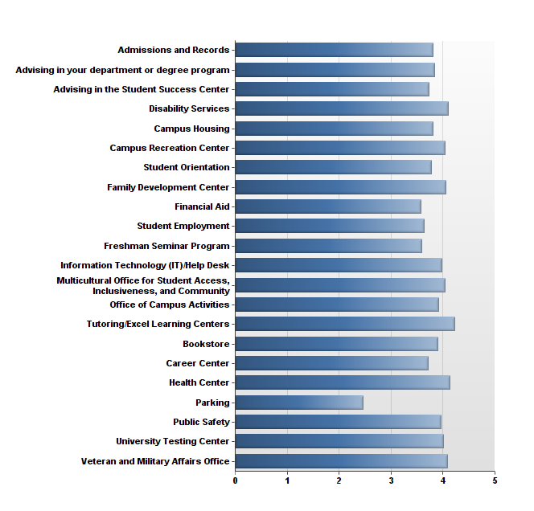
Very Poor

Poor

Fair

Good

Excellent

Question | Very Poor | Poor | Fair | Good | Excellent | Total Responses | Mean
Admissions and Records | 3.08% | 6.41% | 21.28% | 44.62% | 24.62% | 390 | 3.81
Advising in the Student Success Center | 7.17% | 7.53% | 20.43% | 34.77% | 30.11% | 279 | 3.73
Advising in your department or degree program | 4.90% | 9.28% | 14.95% | 38.14% | 32.73% | 388 | 3.85
Bookstore | 2.85% | 3.11% | 21.50% | 46.89% | 25.65% | 386 | 3.89
Campus Housing | 3.60% | 4.50% | 24.32% | 43.24% | 24.32% | 111 | 3.80
Campus Recreation Center | 1.22% | 4.49% | 17.96% | 41.63% | 34.69% | 245 | 4.04
Career Center | 6.64% | 10.43% | 17.54% | 35.55% | 29.86% | 211 | 3.72
Disability Services | 1.56% | 1.56% | 15.63% | 46.88% | 34.38% | 64 | 4.11
Family Development Center | 1.85% | 5.56% | 14.81% | 40.74% | 37.04% | 54 | 4.06
Financial Aid | 6.21% | 13.45% | 22.07% | 33.79% | 24.48% | 290 | 3.57
Freshman Seminar Program | 7.76% | 11.21% | 21.55% | 32.76% | 26.72% | 116 | 3.59
Health Center | 2.23% | 3.91% | 11.73% | 43.02% | 39.11% | 179 | 4.13
Information Technology (IT)/Help Desk | 2.88% | 4.61% | 17.29% | 42.07% | 33.14% | 347 | 3.98
Multicultural Office for Student Access, Inclusiveness, and Community | 3.15% | 2.36% | 14.17% | 47.24% | 33.07% | 127 | 4.05
Office of Campus Activities | 2.92% | 2.92% | 17.54% | 52.05% | 24.56% | 171 | 3.92
Parking | 31.89% | 23.24% | 18.92% | 18.38% | 7.57% | 370 | 2.46
Public Safety | 4.92% | 4.00% | 12.92% | 45.54% | 32.62% | 325 | 3.97
Student Employment | 8.06% | 10.22% | 17.74% | 37.63% | 26.34% | 186 | 3.64
Student Orientation | 3.64% | 6.55% | 19.64% | 49.09% | 21.09% | 275 | 3.77
Tutoring/Excel Learning Centers | 0.93% | 2.80% | 12.62% | 40.19% | 43.46% | 214 | 4.22
University Testing Center | 1.97% | 4.61% | 15.13% | 46.71% | 31.58% | 152 | 4.01
Veteran and Military Affairs Office | 3.45% | 4.60% | 10.34% | 42.53% | 39.08% | 87 | 4.09

19. Approximately how many faculty members took an interest in your educational and career goals?
Answer |  | Response | %
0 |  | 19 | 5%
1-2 |  | 106 | 27%
2-3 |  | 90 | 23%
3+ |  | 176 | 45%
Total |  | 391 | 100%

20. What one piece of advice would you give to a new student attending UCCS?
Text Response
Do not work full time.
That really depends on whether they are a graduate or undergraduate student.
Make sure to have your paperwork in order! Also take advantage of all that campus has to offer, tutoring, socially and any other thing you need is available (even counseling), you just have to make the effort to get the help you need.
Get out and enjoy activities on campus.
Don't try to park on campus between 9AM and 4PM. Just don't.
get a copy of conversation documentation when you meet with an advisor focus and have fun
Work towards creating school pride so future students will benefit
The saying is true, the four ears fly by. Cherish everything about it
Make some friends that you take classes with
Don't if you do not have a job lined up upon graduation
If you don't take it seriously, maybe you should do something different.
Stay focused! Lots of (good) distractions...but lots of ways to get off track.
Turn in the FAFSA by March 1st or you're in trouble.
Use rate my professor to avoid useless classes with uninterested faculty.
College classes are not like high school classes; you have to study to pass. Don't be afraid of dropping a class, it will not hurt your GPA.
Use the resources - especially the writing and communication center. Those are skills that are essential to success in life and there are so many resources at your finger tips.
Finish!
make connections with faculty
Don't just do the coursework and pass the classes so you get a degree. Take this opportunity to truly learn everything you can from your courses and instructors. It's what you learn while you get your degree that helps you do well in a job, not the piece of paper you earned.
Network! Nobody really likes to present in front of a large group of people, but it is a very very important skill to acquire.
Reserve your parking pass early
Park at 4 diamonds take the shuttle
Get involved on campus early on to take advantage of the opportunities here.
Have a career in mind BEFORE you get your degree and get relevant experience ASAP
The main piece of advice I would say is to keep going and don't give up. This is be MUCH harder than high school ever was, but the payout is so much higher and worth it. There will be hard classes that you don't think you will survive in, but if you keep working hard and get to know your professors, you will make it.
Not all instructors are the same and always ask for clarification whether it be for an assignment or your final grade.
focus on time management skills
bum a ride if you can
Find a staff member that is doing something you care about and try to participate.
Don't let Mom and Dad control your life or hold your hand, you will never get anywhere in life if you expect others to do things for you.
Always ask questions. Get to know your professor. They are here to help you succeed.
Make sure to keep track of your own classes and credits and don't count on the advising department to advise you appropriately.
If you go for a teaching option, make sure you check on your own paperwork and don't trust the office when they tell you multiple times that they sent in your paperwork. They told me every time (at least 5 times) I called that they had sent it in and never did. Just be cautious because it could ruin your whole first year as a teacher!
Study well for good grades and take use of the career center.
Don't go, if you are over the age of 45. College too concentrated on young students on this largely commuting campus.
Try to become involved with student organizations early. I was not actively a part of student life until my junior year, and I wish I was more active during my first half of my college experience.
Order books online from amazon.com it will save you $$$ on textbooks.
get involved and find your passion
Get involved in the community, UCCS has the resources use them!
Get involved!
ASK QUESTIONS. Get over yourself and realize that the professors are there to help you and truly will help you. It killed me to not ask questions thinking that I understood something when I actually didn't. And develop relationships with professors and students. 100% of my current job placement came from a relationship that I developed at UCCS not a resume I submitted to a career-placement organization.
Rent your textbooks. The bookstore is expensive.
Take advantage of the activities given, and always choose to live on campus the first year, that's how you make most of your friends
Work. Hard.
Car pool if possible to share parking costs; watch out for speed traps on Austin Bluffs Parkway
BE mindful of the experience you are about to have.. don't worry so much about the future.. just enjoy your time on campus.. and try to meet as many diverse individuals that you can... and pay attention to the required classes!
Don't bother to buy a parking permit because parking is limited and the cost is WAY too high.
Avoid Eric Schubert as an instructor at all costs. As a teacher he is a bully and his grading is entirely unfair, and UCCS doesn't seem to mind enough to do anything about it.
This University is challenging and will push you.
Do your own practice and research to learn and gain hands on knowledge in areas that are relevant to industry before you graduate.
Take lots of electives, more than are required.
Get in, get out, get on with your life. In all seriousness, I would say to make sure you value your education and know why you are in school. You will get the same amount of benefit out of your education as the effort that you put in.
Just make sure you always go to class, find a major you love because you are going to be in that field the rest of your life! Try to avoid doing the stupid stuff people do in college but have fun!
Nothing will be given to you. You will earn everything you get.
Try to get in state tuition from the beginning because the office fights every attempt, like driving your parents car in Colorado and it’s not in your name so it has your previous state's plates and insurance, which resulted in me being denied and having to take out more loans, which will take me an additional 10 or so years to pay off.
Get an internship!
Talk to your professors as much as possible. You will need them in the future.
Do not rush through things, take advantage of all the services offered.
Plan ahead with prerequisites in order to take advanced courses or get a minor in a different field. Use electives strategically.
Be prepared to read a lot.
Get involved and make your voice heard
Don't be afraid to ask questions in class.
My biggest piece of advice would be to get to know your professors. Not all will be great, but when you do find a great professor, they will surely have a profound impact on your academic, career, and personal life.
Get an internship as soon as possible.
Don't expect too much. You will learn more from reading your textbooks. Heads down in the cs dept, if they are a phdbe very careful of what they say, it is frequently wrong. The lecturers and instructors are more helpful than most of the professors.
Get Involved In Campus Activities To Meet People!!!!!
Get connected: join a group on campus, make friends in class, utilize the excel centers, go to office hrs
plan to spend a lot of money!!!
Get involved and buy in to the school because it is on the verge of being great
Do not pay for parking; the prices are outrageous and you will never find a spot. Take the time to choose your major, the faculty are great at helping to guide you on your journey.
Make sure you have your degree planned out, along with the required ancillary activities for your chosen career (assuming you have one in mind).
study hard or just go home and don't waste both of our time.
Have the drive and willpower to see it through, because you’re only going to get out of it what you put into it.
Take time to get to know your professors.
Take advantage of all opportunities that come your way. Always say "yes." Know that every person that you meet wants another friend. So never be shy to introduce yourself.
It seems like a great school for freshman that need a small campus in a fairly large city with plenty of things to do. It's great for continuing education students that want night classes.
Ask questions, no question is a silly question .
Don't be afraid of the faculty: They are here to help you succeed.
Don't take a Dr. Wilcox class
Read the assignments
Keep an open mind and take classes out of your comfort zone.
Take advantage of the various services offered such as career counseling, student advising, recreation center, and writing center.
Get involved in side projects; you won't get enough real world experience without doing so.
Communicate effectively with your professors! They really do want you to succeed!
Take risks by getting involved in things outside your comfort zone.
Join a club that does activities on campus. It can be very easy to isolate yourself from the fun that is available at the school. You only get to be an 18-22 year old first-time college student once, so don't miss out on making friends and having fun! It's college! Yeah!
Learn as much as possible
Take the time to talk to your professors when you are having a problem. They are usually very willing to help if they can.
Get involved, participate, enjoy!
Nursing students- just focus and you will get through it. It is challenging every day, but you will get there!
Get involved in at least one club or activity.
College means you make decisions for your life and yours alone - nobody else can make them for you. Don't blame others for being unsuccessful - you can be your own driving force to make whatever change you want happen in your life so make college count because it may be the only chance you get to make a difference in the world.
Do not slack during your first couple of semesters because the 1000 level classes are harder than upper level classes, get a good GPA, it is hard to raise it once it is low.
Get to know your professors outside of class
Ride a motorcycle as much as possible.
Take advantage of the equipment rental at rec center
Get involved in something on campus early
Get to class early because parking is awful.
Speak up in class and challenge the status quo.
Work on networking. You'll learn quite a bit, but the degree won't get you far.
Spend as much time as possible interacting with your fellow classmates.

21. Are you affiliated with the military?
Answer |  | Response | %
My spouse is in the military. |  | 23 | 6%
I am a member of the military. |  | 13 | 3%
I am a veteran. |  | 42 | 11%
My mother or father is in the military. |  | 35 | 9%
No, I am not affiliated with the military. |  | 265 | 68%
Other, please specify. |  | 23 | 6%

Other, please specify.
My douse is a veteran
Family members
Reserves
my son is in the AF reserves
retired Army officer
My company is a military contractor
My father, brother, and many other family members have served in the military.
I used my father's post-9/11 GI Bill to attend
In the process of joining the Marines as an officer.
Father was in the military
my son is in the military
Dept of Defense Civilian
brother
my father is retired military
contractor
Boyfriend
I am a defense contractor
Retired Military
My parents were in the military and I work on Fort Carson
My grandfather was in the Military
Dad is retired Military
Fiancé
My stepmother was in the military.

22. Were you a Colorado resident when you enrolled at UCCS?
# | Answer |  | Response | %
1 | Yes |  | 324 | 83%
2 | No |  | 68 | 17%
 | Total |  | 392 | 100%

23. Are you a first-generation student?
Answer |  | Response | %
Yes |  | 122 | 31%
No |  | 266 | 68%
Not sure |  | 6 | 2%
Total |  | 394 | 100%

24. Please mark the highest level of education achieved by your parent(s).
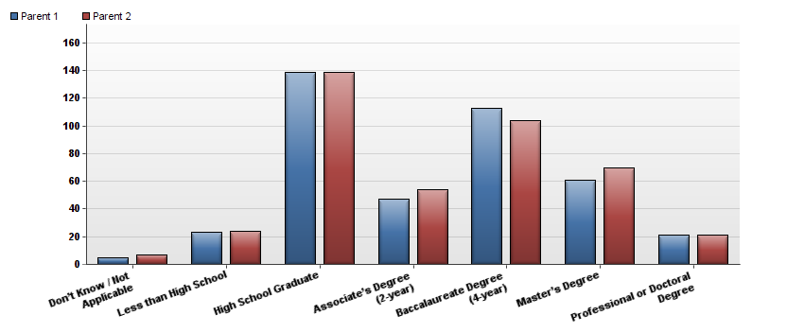

Question | Parent 1 | Parent 2 | Total Responses
Don’t Know / Not Applicable | 5 | 7 | 12
Less than High School | 23 | 24 | 47
High School Graduate | 139 | 139 | 278
Associate’s Degree (2-year) | 47 | 54 | 101
Baccalaureate Degree (4-year) | 113 | 104 | 217
Master’s Degree | 61 | 70 | 131
Professional or Doctoral Degree | 21 | 21 | 42

25. How many dependents (children or elderly persons) did you care for in your household while you were enrolled at UCCS?
Answer |  | Response | %
0 |  | 298 | 75%
1 |  | 48 | 12%
2 |  | 25 | 6%
3 |  | 17 | 4%
4 |  | 4 | 1%
5+ |  | 3 | 1%
Total |  | 395 | 100%

26. What would you have done had you not attended UCCS?
Answer |  | Response | %
I would have attended a college/university outside of the Colorado Springs metro area. |  | 170 | 43%
I would have attended a different college/university in my immediate area. |  | 142 | 36%
Other |  | 42 | 11%
I would have delayed attending college. |  | 41 | 10%
I would not have attended college anywhere. |  | 35 | 9%
I would have enrolled in an online program. |  | 33 | 8%

