How to Get Your FCQ Reports
Contents
Get FCQ reports out of EvaluationKit 1
See FCQ reports inside DigitalMeasures 2
Uploading FCQs in a DigitalMeasures Workflow (faculty review) 3

Get FCQ reports out of EvaluationKit

Faculty will receive an email notification when FCQ results are ready. The email notification includes a Login link and it takes the faculty to their specific dashboard inside EvaluationKit.

Navigate to the Project Results and click the project name (e.g. “Fall 2020 Main Session”) and it opens a page with a course list. There are two potential ways to download the reports:
  - Click the download icon under the column called Report.
  - Or, if available, click the “Batch Report” link and select whether you want multiple reports, collated reports, or one report with all the data combined. You may download and re-download as often as you wish. You might choose a batch report with combined data if you have two sections of a course that you want to examine as a combined course.
As we administer FCQs in future semesters, the results will be added to the dashboards organized by Project. A Project will represent the semester (“Fall 2020”) and the session within that semester (“Main Session” or “Session B” as examples).
Note: If you see a large, purple button like this 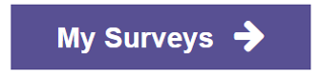it is a link to FCQ surveys that you are expected to complete as a student. Some instructors are also students and their dashboard will include both roles. Instructors who are not students will not see the My Surveys button at all. The My Surveys button does not take you to the reports intended for instructors.
Figure 1. Sreenshot of a dashboard for person with instructor and student roles
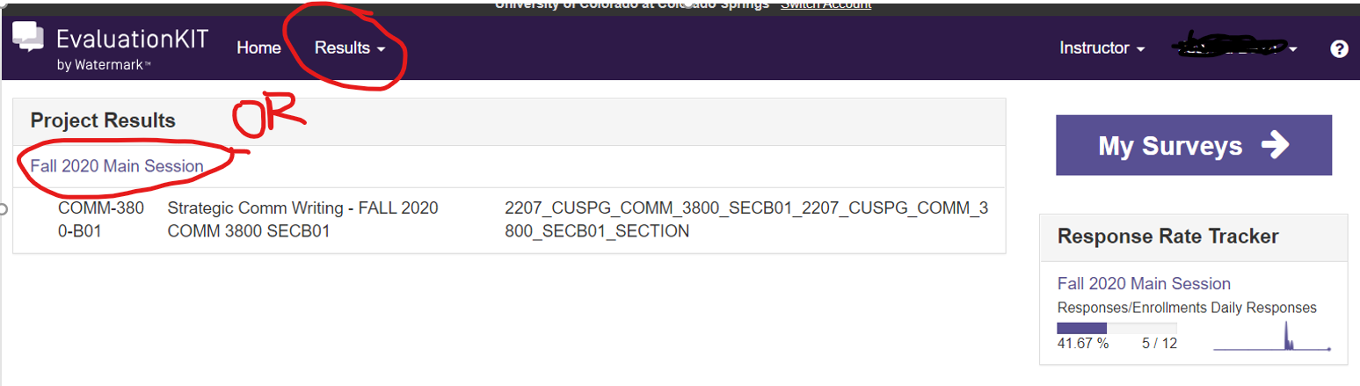
Figure 2. Screenshot of a dashboard for a person with instructor role only (not a student)
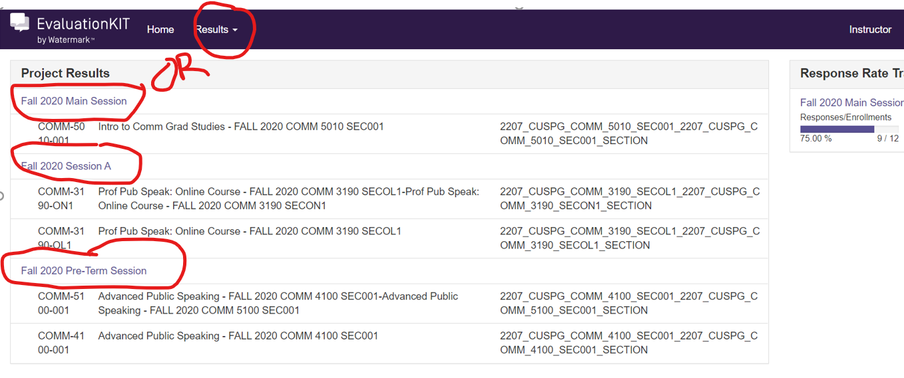
Figure 3. Sceenshot of the results page in the dashboard
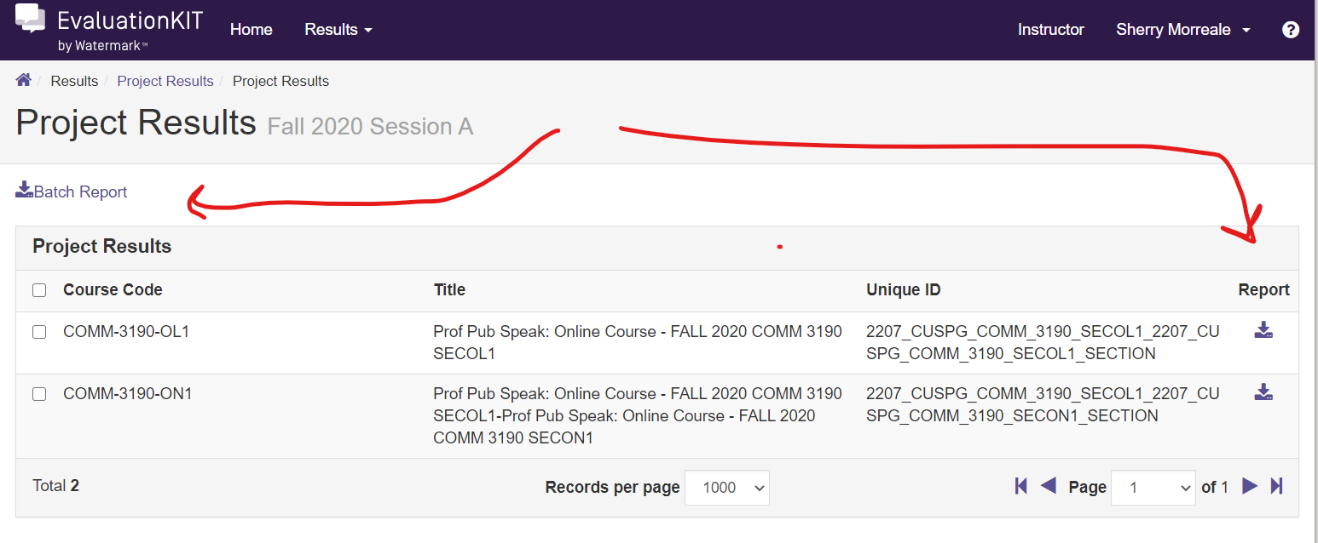

See FCQ reports inside DigitalMeasures

For your convenience, we are migrating FCQ reports into DigitalMeasures. The “detailed report with comments” will appear next to the course listed in the Scheduled Teaching area of your account in Digital Measures. Clicking on the “Course Evaluation” link will open the report in PDF format. If a course is listed without a course evaluation link, the evaluation either does not yet exist or the EvaluationKit FCQ report does not match the course and instructor information in the existing records.
Figure 4. Screenshot of course evaluations in Scheduled Teaching within DigitalMeasures
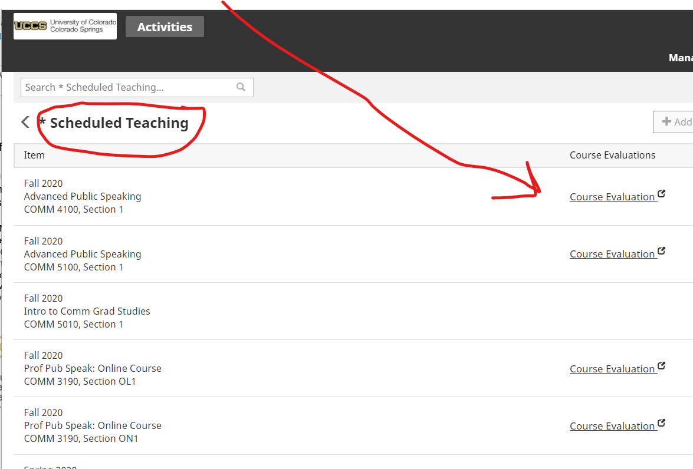

Uploading FCQs in a DigitalMeasures Workflow (faculty review)

We have not yet been able to automatically load an individual’s FCQ reports inside a workflow, which is a process within DigitalMeasures that we use to conduct faculty reviews. Faculty undergoing a review are prompted to upload their FCQ reports one by one. Thus, faculty will need to download the FCQ reports from either Scheduled Teaching or EvaluationKit and then re-upload them within a workflow.
Figure 5. Screenshot of an upload prompt within a workflow
