How to Run Reports for a Group of Faculty

Login to Digital Measures and navigate to Reports at the top of the main screen. The reports that you have access to will be listed. Your role as a faculty member, chair, and/or college administrator will determine which reports are listed. There are two ways to run a report for a group of faculty and it depends on how the report was created: by Digital Measures or a UCCS user.

FOR A REPORT CREATED BY DIGITAL MEASURES
If created by Digital Measures, then click the name of the report. On the screen that opens, make your selections in each numbered area.
  - Be sure to select a date range for the activities you want to include.
  - Click on “Change Selection” in order to select an entire college, department, or a handful of individuals.
  - Check the report options. The default settings might not be best for you.
  - Indicate the file format (usually Word, PDF, or sometimes CSV).
  - After making your selections, click the RUN REPORT button on the top right area of the screen. Depending on the report, you might get one downloaded file for the group or one file per individual in the group.

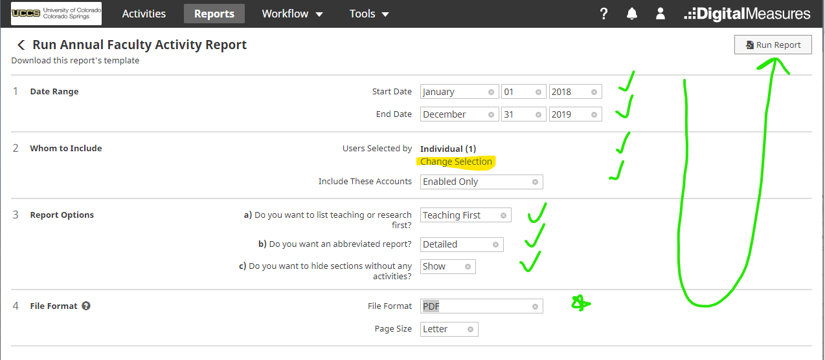

FOR A REPORT CREATED BY SOMEBODY ELSE
If the report was created by Institutional Research, the author will be “working group.” It is possible for other colleagues to create and share their reports, so if it is created by anybody other than Digital Measures, click the name of the report and do as follows:

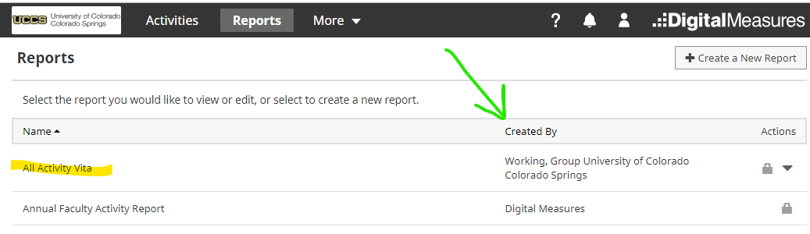
- Clicking the name of the report will open into a report for a single person…click Options on the top-right of the page. This opens up the menu. (See the picture below this paragraph.)
- Select the date range filter to limit the activities within a year or whatever time frame you choose.
- Select GROUP icon to choose all of the faculty in a college or department or to choose a specific group of individuals.
- When selecting a group in the Scope or Selection boxes, be sure to click the ADD button to see your list in the popup window.
- DO CHOOSE THE EXPORT BUTTONS AT THE BOTTOM OF THE GROUP WINDOW! If you choose the export option on the top right, you will export only the report you are previewing rather than the whole group you have selected.
